AIM Student User Guide: Requesting Accommodations

Students affiliated with the Disability Resource Center (DRC) whose reasonable accommodations have been determined must initiate the process of generating Faculty Notification Letters (FNL) for their courses. The FNL verifies that the student has a documented disability and/or medical/mental health condition and lists the eligible accommodations the student chooses to use in each course. It is the student's responsibility to prepare a FNL for each course in which they intend to use the approved accommodations. FNLs are effective until the end of the semester.

To request accommodations, please follow the steps below. Once a request is submitted, the information is sent to the Instructor Portal, where instructors can view students’ FNL.

Step 1: Go to the [**Disability Resource Center**](https://studentsuccess.uky.edu/disability-resource-center) homepage and select **AIM Access** from the top navigation menu.

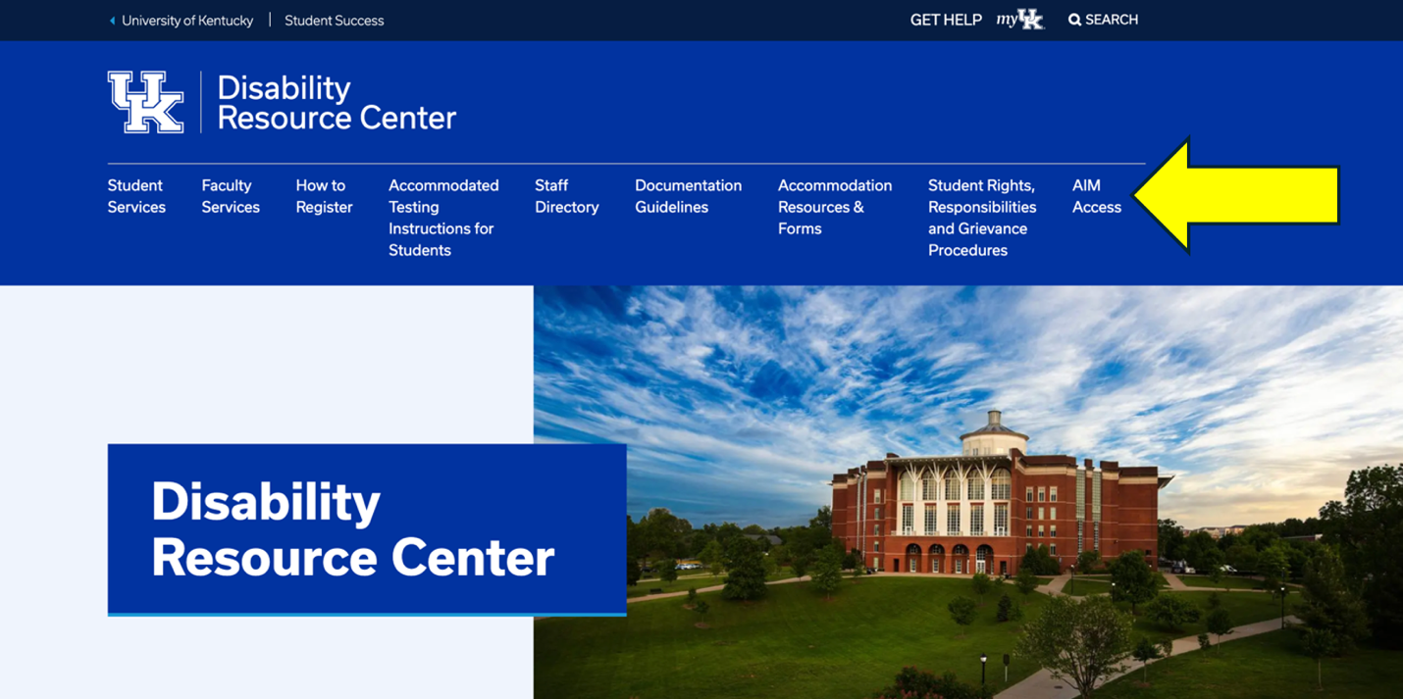

Step 2: Log into [**AIM Student Portal**](https://hayes.accessiblelearning.com/UKY) with your single sign on (SSO) credentials, which are your UKY LinkBlue username and password. **Tip:** Consider bookmarking this link for accessing AIM in the future.

# Image of the DRC website, AIM Access. AIM student portal login is located in a light blue box with a dark blue button with the words log in.

# Step 3: Review and acknowledge any **E-form Agreements**. Documents requiring students’ attention will be listed on student’s dashboard.

Notification highlighted in the student portal of a required e-form agreement rights and responsibilities when accessing the student dashboard in AIM.



Step 4: Locate **My Dashboard** on the left side menu and select **Overview**. This will show **Accommodation Requests** for specific terms. Identify the current term and **Add Requests** for each class by selecting the plus icon.

**AIM Student portal image with yellow arrows pointing to the left side navigation menu titled My Dashboard where students can select Overview. In the body of the webpage is another yellow arrow pointing to a plus icon to add request for a class.

**

Step 5: Select the courses you want to request accommodations for. To request accommodations, select the checkbox(es) next to each course. If you need to apply the *same* accommodations for all selected courses, select the checkbox next to that option and **Continue to Next Step**. If you want to *customize* your accommodations per course, after you select the checkboxes next to each course, proceed to the next page by selecting **Continue to Next Step** to choose your eligible accommodations.

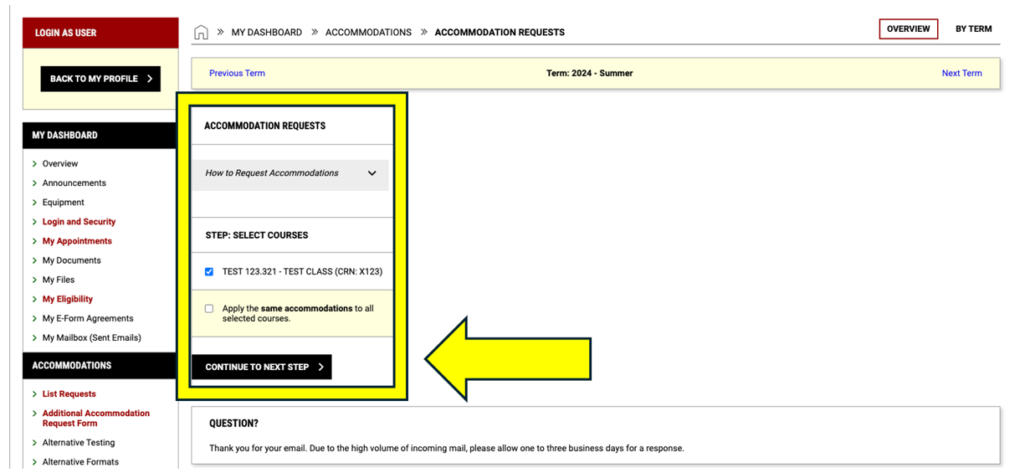

Step 6: Select Accommodations for each course by marking the checkbox next to the accommodation you need to use for that course. If you need to use all accommodations, select the first checkbox, **Select All**. If you do not need accommodations for a course, select the last checkbox, **I do not need accommodations for this course**. When you are done with your selections, select **Submit Request.** This information is then sent to the instructor portal where instructors view students’ FNL.

***\* Please be advised, students no longer need to send their accommodation letters to each instructor. Instructors can now access these letters directly through their Instructor Portal. However, students must still meet with each instructor at the beginning of each semester to discuss their accommodations.***

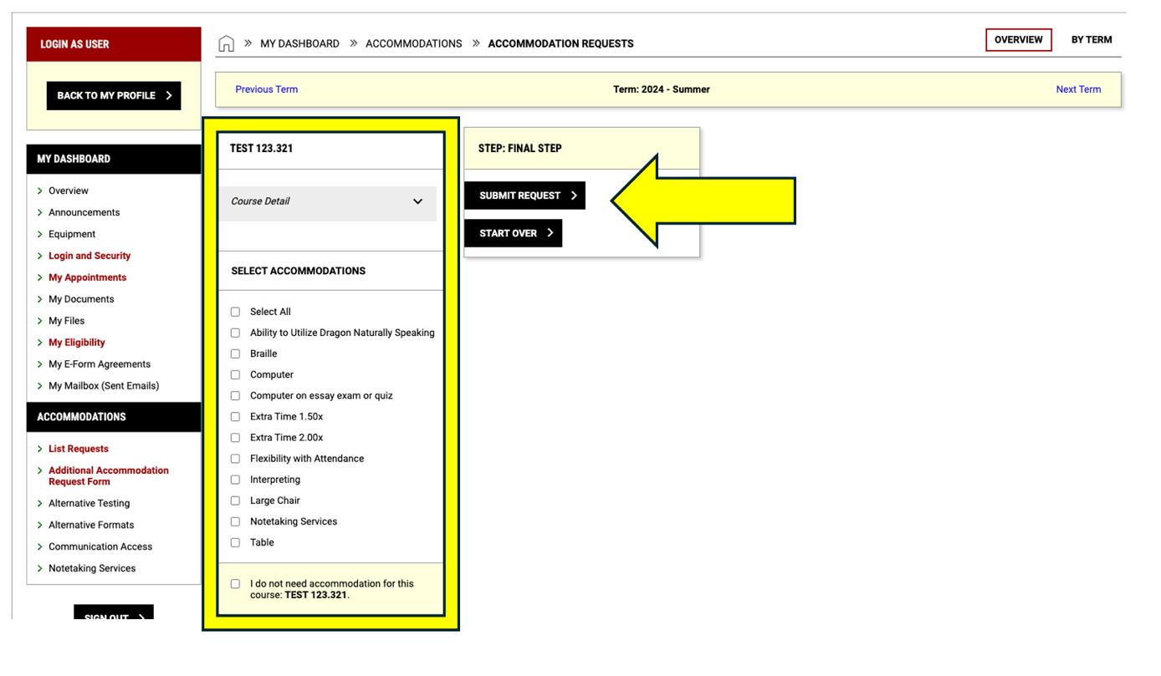

Step 7: Notification the submission of your request(s) was a success.

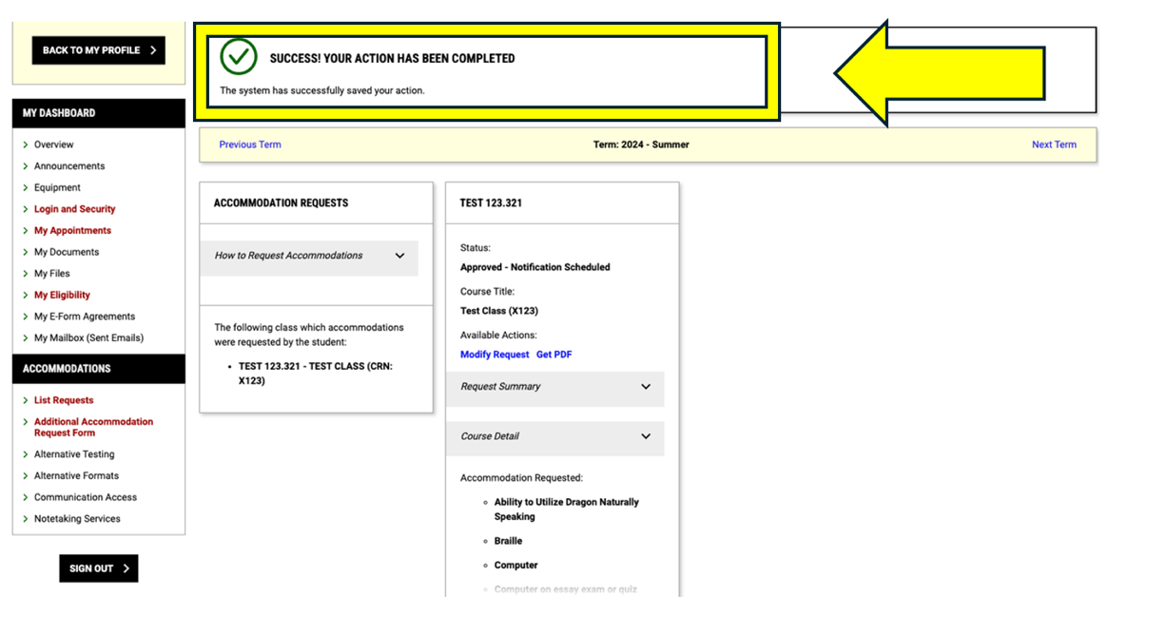

Step 8: To view requests made or to modify requests, return to Dashboard, select **List Requests** on the left side menu under **Accommodations**. A green check mark indicates requests have been made for the current term and can be viewed by selecting **View All Requests.**

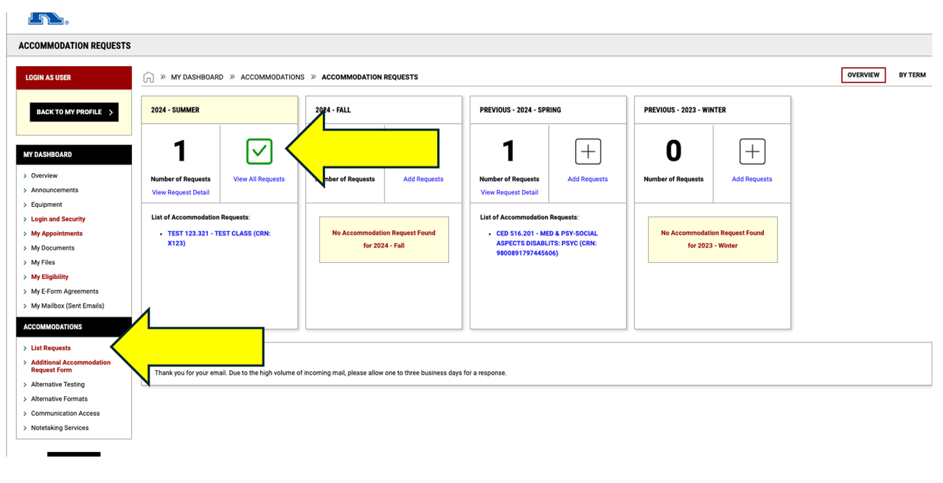

Select **Modify Request.**

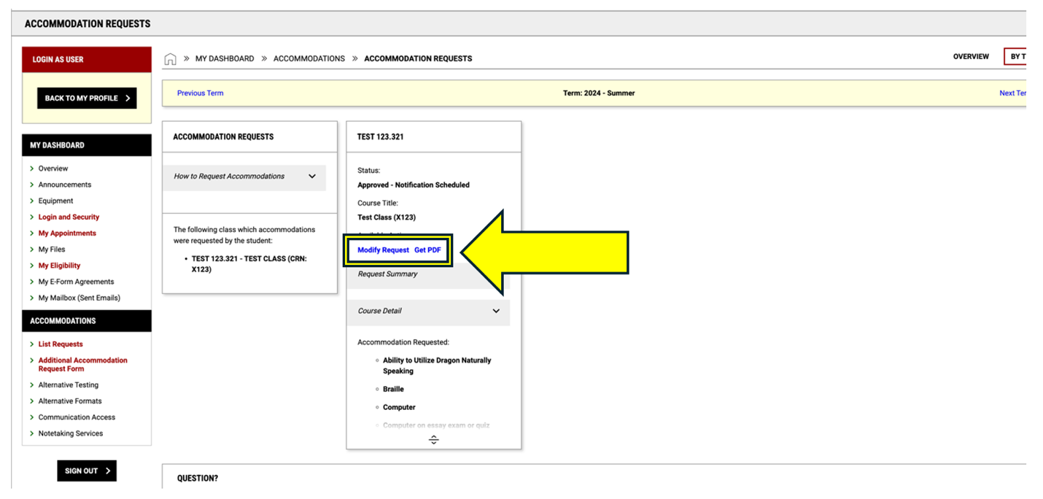

Modify accommodations as needed and select **Update Request**. You may also generate a PDF of your FNL to have during your meeting with instructors by selecting, **Generate PDF**.

AIM student portal showing accommodation requests where students can generate PDF or update request or cancel request.



***\*If a course you are enrolled in is not listed or if you need assistance, please contact your consultant. Information about your assigned consultant can be found on the Student Portal dashboard under the Overview section.***

